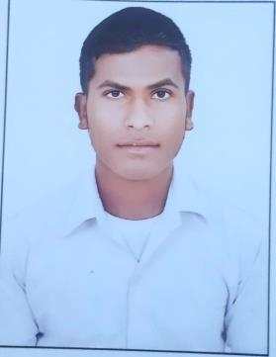**RESUME**

Name : vrandavan baiga

Mobile :+91 9302726504

Email ID: vrandavanbaiga712@gmail.com

Address:- s/o Sonshah baiga, Ward no.06,Village : Pipari

Post : Chhakta District : Shahdol (M.P) 484771

|  |
| --- |
| **career objectiv** |

to work with a reputed organization which will provide me with opportunities to utile sklls,avhiece

creativity and grow professionally.

**Skills**

Typing /ms word/ms excel/ PowerPoint computer all work.

**Qualification**

|  |  |  |  |  |
| --- | --- | --- | --- | --- |
| S.NO | PROGRAM/DEGREE | BOARD | YEAR | PERCENT |
| 01 | 10th | MP board | 2021 | 76% |
| 02 | 12th | MP board | 2023 | 72.2% |

**PERSONAL DETAIL-**

Name : Vrandavan Baiga

Father's Name : Sonshah Baiga

Mother's Name : Phoolmati Baiga

Date of Birth : 16-08-2005

Marital status : Unmarried

Gender : Male

Nationality : Indian

Language Known : Hindi

**Declaration**

I hereby declare that set ail famished herein are to the best my knowledge and belief. Wherever applicable, I can provide documents in original to substantiate any information preceded here

Date: …………….. Signature

Place: ……………. (Vrandavan Baiga)