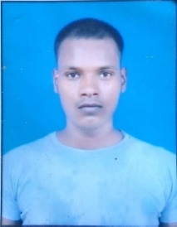RESUME

**Suraj Kumar**

**ADD:**  Village+p.o+p.s-Goraul

vaishali(bihar)844118

**Mob**. **:** 7870782494,7870781355

**Email ID:** [surajkumar15846@gmail.com](mailto:surajkumar15846@gmail.com)

**Aadhar number:494711248375**

**CAREER OBJECTIVE**

To seek a dynamic and challenging career an organization strives for excellence with my knowledge and team effort while making positive contribution to promote the individual opportunity and professional growth.

**ACADMIC QUALIFICATION**

|  |  |  |  |  |  |
| --- | --- | --- | --- | --- | --- |
| **Sr.No.** | **CLASS** | **BOARD/UNIVERSITY** | **MARK’S** | **YEAR** | **DIVISION** |
| 1. | High School | B.S.E.B patna | 263 | 2010 | 2 nd division |
| 2. | Intermediate | B.S.E.B patna | 225 | 2012 | 2 nd division |
| 3. | B.a | B.R.A.B.U muzffarpur | 430 | 2017 | Second class |

**COMPUTER SKILLS**

* Course on A.D.C.A 2019 in muzaffarpur
* Computer hardware&networking 2018 in rudest hajipur
* F.T.C.P 2019 in hajipur

**STRENGTH FACTOR**

Good strength of working with team, Strong ability to work creative & determination.

**PERSONAL PROFILE**

Father Name : Hari kumar singh

Date of Birth : 06/05/1995

Marital status : unmarried

Gender : Male

Religion : Hindu

Nationality : Indian

**DECLLERATION**

I do hereby declare that the statements made in this document are true to the best of my knowledge and belief.

Place:………

Date:……….. (Suraj Kumar)