CURRICULUM –VITAE

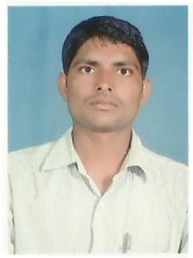
SHIV RAM YADAV
Mobile No: +91-9936703222 ADDRESS:- Email- shivram345@gmail.com VILL- MIDIURA, POST- SHAHIPUR
DIST- ALLAHABAD-221503 (U.P)

Objective:-
- To work in an organization where I can utilize my skills and abilities and learn more, ensuring my professional growth in the process.
Computer Knowledge
- One Year Post Graduate Diploma Course in Accountancy (With Computrised Accounts & Taxation) from Board of Technical Education U.P. Lucknow.
- DCA from Professional Computer Academy Handia Allahabad.

Experience :-

- One year experience in Computer Ex. In Evergreen Infrazone India Limited.
- Two year experience EVERGREEN MULTISTATE CO-OPERATIVE SOCIETY LTD from Jan 2015
- Current job Debt Recovery Agent & Business Correspondents in AISECT Ltd 2018

Academic Qualification:-

- M.com in 2010 from Purvanchal University with Second Division 665/ 1200 (55.41%).
- B.Com in 2008 from Purvanchal University with Second Division 922/1800 (51.22%).
- Intermediate (Commerce) in 2005 from U.P. Board with First Division 704/1000 (70.40%).
- High School (Commerce) in 2003 from U.P. Board with Third Division (265/600) (44.16%).
PERSONAL DETAILS
- Name | : | SHIV RAM YADAV YADAV
- Date of Birth | : | 15-01-1987
- Father’s Name | : | Shri. Lallan Yadav
- Nationality | : | Indian
- Martial Status | : | Married
- Language Known | : | English, Hindi
- Hobbies | : | Reading News Paper & Listing Song
- Gender | : | Male
- Correspondence Address | : | Vill-Midiura Post-Shahipur Handia Allahabad -221503 U.P

DECLARATION

I hereby declare that all the above information is given by me is true to the best of my knowledge and belief.

Date 20/04/2024…

Place Allahabad… (SHIV RAM YADAV)

