**KANCHAN SHARMA** 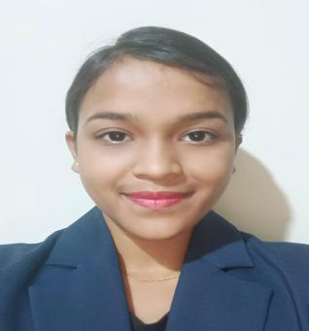

Gaytri hills sub station

Hyderabad , 500045

9515762414

Kanchansharma9515@gmail.comA long, thin rectangle to divide sections of the document

# **CAREER OBJECTIVE**

Seeking a challenging position in the service industry where I can enhance my skills, expand my knowledge, prove my abilities and leverage my learning making the best of my potential in a reputed organization resulting in mutual growth.

**EDUCATION**

Diploma in Aviation Hospitality and Travel from Frankinn Institute of Airhostess Training, Kukatpally, Hyderabad

## Intermediate :

## Gnana Deepika Junior College, Madhapur Hyderabad

**SSC**

Little Girls High School, Gayatri Hills, Hyderabad

**TECHNICAL SKILLS**

Amadeus Software (Travel reservation)

Fidelio Software ( Hotel reservation)

**ATTRIBUTES:**

* Multitasking
* Cultural awareness
* Interpersonal skills
* Decisive and rational
* Self motivated
* Active listener
* Teamwork and collaboration
* Flexible and adaptive

.**HOBBIES**

* Arts and craft
* Reading novels and digital comics
* singing
* Work out

# **AWARDS**

* Gold medal in international championship of karate and taekwondo.
* Silver medal in Rhetorica competition
* Gold medal in drawing competition.

**PERSONAL** **DETAILS**

# Father’s Name : Mahesh Sharma

Date of Birth : 11/3/2004

Marital Status: Un-married

Passport Number:

Height: 155 cms

Weight: 52kgs

BMI: 21.3

Languages known : Hindi, English, Telugu, Maithili & , Bhojpuri.

Place:

Date: KANCHAN SHARMA