**RESUME**

Sakshi Patel

Killapara Patel Mohalla Word No.39 Rajnandgaon (C.G)

Contact: 70********

E-mail: [Sakshi*********@gmail.com](mailto:Sakshi*********@gmail.com)

**Objective**

I want to excel in this field with hard work, perseverance and dedication.

**Educational Qualification**

|  |  |  |
| --- | --- | --- |
| **Courses** | **Board/ University** | **Passing Year** |
| 10th | CGBOARD | 2015 |
| 12th | CGBOARD | 2017 |
| Diploma In Electronics & Telecommunication | Swami Vivekananda Technical University | 2020 |
| Graduation Bachelor Of Arts | Hemchand Yandi University Durg | 2024 |

**Technical Skills**

Basic Computer Knowledge

Data entry operator

Typing

**Hobbies**

Drawing, Painting, Rangoli, Mehndi, Craft Making, Travelling, Dancing.

**Personal Detail**

Name: - Sakshi Patel

Father’s Name: - Mr. Kishor Patel

Mother’s Name: - Mrs.Mamta Patel

Date of Birth: - 30/01/2001

Contact: - 70********

Nationality: - Indian

Language: - Hindi

**Declaration**

I hereby affirm that all the best above information in this document is true to best of my knowledge.

**Thank you.**

**Place:** Rajnandgaon

**Date:**

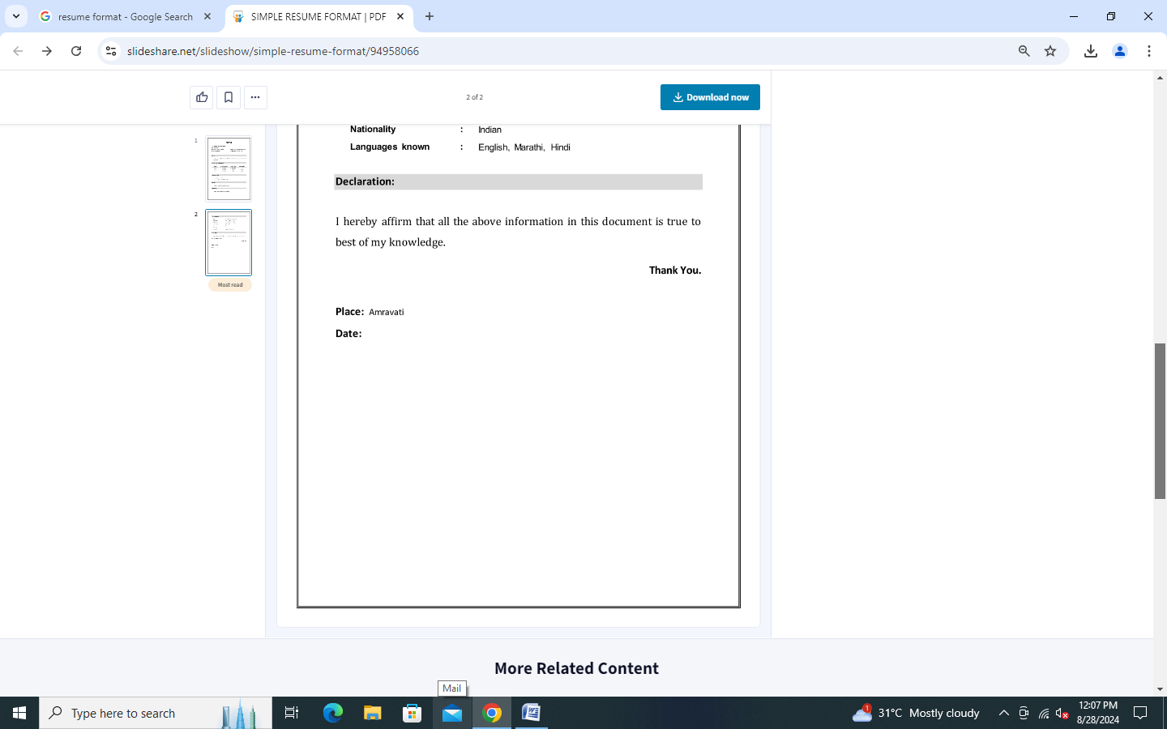

**RESUME**

Sakshi Patel

Killapara Patel Mohalla Word No.39 Rajnandgaon (C.G)

Contact: 70********

E-mail: [Sakshi*********@gmail.com](mailto:Sakshi*********@gmail.com)

**Objective**

I want to excel in this field with hard work, perseverance and dedication.

**Educational Qualification**

|  |  |  |
| --- | --- | --- |
| **Courses** | **Board/ University** | **Passing Year** |
| 10th | CGBOARD | 2015 |
| 12th | CGBOARD | 2017 |
| Diploma In Electronics & Telecommunication | Swami Vivekananda Technical University | 2020 |
| Graduation Bachelor Of Arts | Hemchand Yandi University Durg | 2024 |

**Technical Skills**

Basic Computer Knowledge

Data entry operator

Typing

**Hobbies**

Drawing, Painting, Rangoli, Mehndi, Craft Making, Travelling, Dancing.

**Experience**

Customer Support

**Personal Detail**

Name: - Sakshi Patel

Father’s Name: - Mr. Kishor Patel

Mother’s Name: - Mrs.Mamta Patel

Date of Birth: - 30/01/2001

Contact: - 70********

Nationality: - Indian

Language: - Hindi

**Declaration**

I hereby affirm that all the best above information in this document is true to best of my knowledge.

**Thank you.**

**Place:** Rajnandgaon

**Date:**