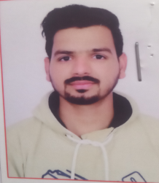**RESUME**

**ROHIT SURYAVANSHI**

**+91 82230 16261**

Email id : [rohitsurya841@gmail.com](mailto:rohitsurya841@gmail.com)

**OBJECTIVE**

To work with an organization where can learn new skills and increase my abilities for the organizational goals as well as myself.

**EDUCATIONAL QUALIFICATION**

* Passed out B.SC from SWAMI VIVEKANAND COLLEGE SEHORE (M.P)
* Passed out 12th from M.P BOARD BHOPAL
* Passed out 10th from M.P. BOARD BHOPAL

**OTHER ACADAMIC DETAILS**

* Pursuing **D.M.L.T** from IES UNIVERSITY, BHOPAL
* Passed out **Tally ERP9**
* Passed Out **P.G.D.C.A** from MCU BHOPAL

**TECHNICAL SKILLS**

* Advance computer knowledge
* Tally Expriance

**WORK EXPERIENCE**

* 2 Year Expriance As Data Entry Operater ( Nagar Palika Sehore)
* Sales Executive & Accounted (Sahara Private iti College Sehore)

**STRENGTH & HOBBIES**

* Hard & Smart Working
* Honest & Punctual
* Good Communication skill
* Arts, Drawing Cricket, Reading books

**PERSONAL DETAILS**

Father’s Name :- Mr. Mangesh Suryavanshi

Address :- Umrao Patel Ka Bagicha Station Raod

Sehore

Marital Status :- Single

Date…………………………………. (Rohit Suryavanshi)