**Resume**

ACADEMIC QUALIFICATION



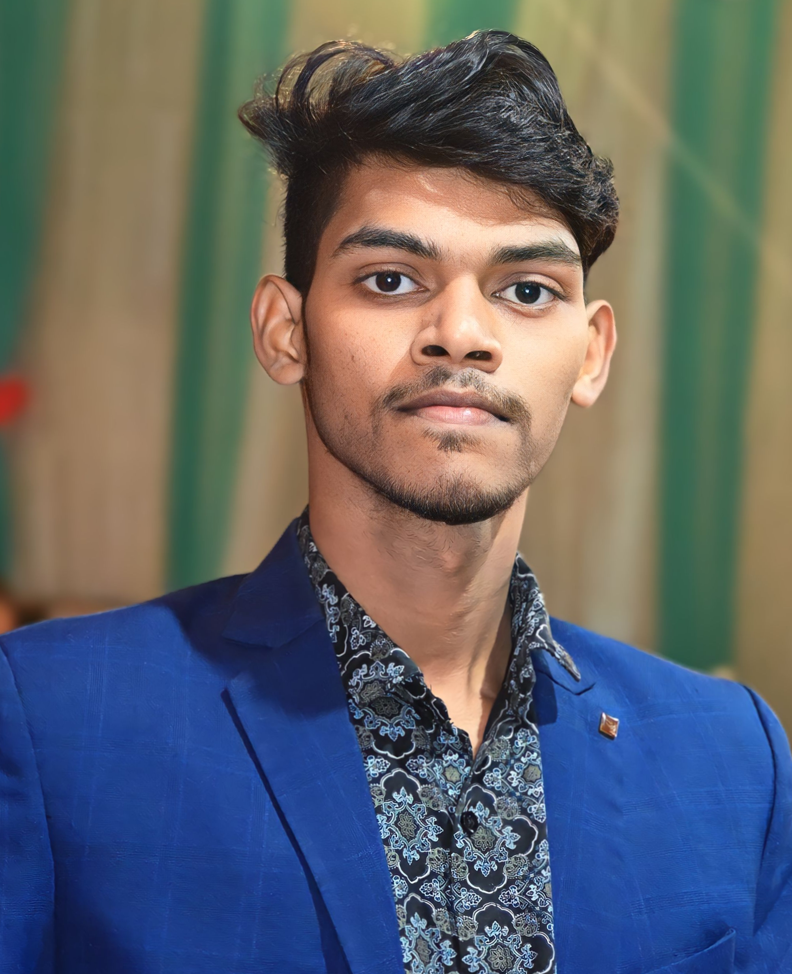

**ANURAG KANT**

**CAREEROBJECTIVE**

* Secure a responsible career opportunity to fully utilize my talent and skills to grow, while making a significant contributiontothesuccessofthe company.

**CONTACTDETAILS**

* Mobile No. 6205287265
* Email id [anuragkant27@gmail.com](mailto:anuragkant27@gmail.com)

**ADDRESS**

* SHYAMVER BHAVAN SHIVPURIHAZARIBAGH

|  |  |  |  |  |
| --- | --- | --- | --- | --- |
| **Exam Name** | **Board / University** | **Passing year** | **Percentageof Marks** | **Division** |
| 10th | JAC | 2022 | 50.20 | 2nd |

PROFESSIONAL QUALIFICATION

|  |  |  |  |  |
| --- | --- | --- | --- | --- |
| **Exam Name** | **Board / University** | **Passing year** | **Percentageof Marks** | **Division** |
| 12th | JAC | 2024 | 43.6% | 3rd |

EXTRA QUALIFICATION

* Domestic Data Entry Operator

WORK EXPERIENCE

* FRESHER

PERSONAL DETAILS

|  |  |
| --- | --- |
| **Date of Birth** | 25-11-2004 |
| **Father's Name** | RAJU KANT |
| **Mother's Name** | SUNITA KANT |
| **Nationality** | INDIAN |
| **Marital Status** | Unmarried |
| **Language** | Hindi |
| **Hobbies** | Cricket |

Declaration:

Iherebydeclarethatallthestatementmadeinthisresumearetrue, complete and correct to the Knowledge.

Date:

Place: (ANURAG KANT )