**Resume**

ACADEMIC QUALIFICATION

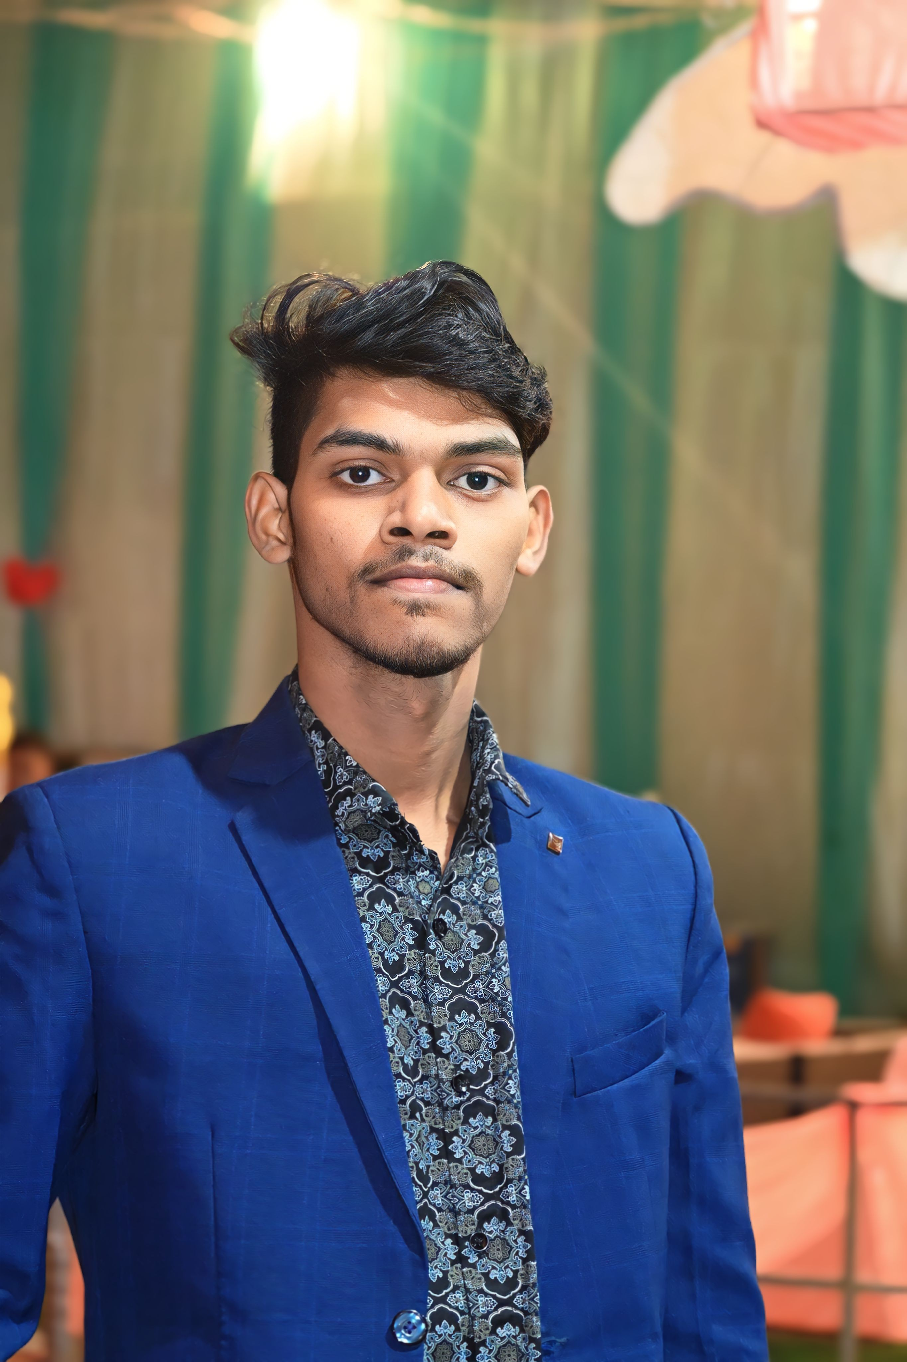

**RAUSHAN KUMAR VERMA**

**CAREEROBJECTIVE**

* Secure a responsible career opportunity to fully utilize my talent and skills to grow, while making a significant contributiontothesuccessofthe company.

**CONTACTDETAILS**

* Mobile No. 7654819115
* Email id rkv3924@gmail.com

**ADDRESS**

* VILL- DARI, SINARIYA,CHATA ,JHARKHAND,

|  |  |  |  |  |
| --- | --- | --- | --- | --- |
| **Exam Name** | **Board / University** | **Passing year** | **Percentageof Marks** | **Division** |
| 10th | CBSE | 2022 | 68.4 | 1ST |

PROFESSIONAL QUALIFICATION

|  |  |  |  |  |
| --- | --- | --- | --- | --- |
| **Exam Name** | **Board / University** | **Passing year** | **Percentageof Marks** | **Division** |
|  |  |  |  |  |

EXTRA QUALIFICATION

* Domestic Data Entry Operator

WORK EXPERIENCE

* FRESHER

PERSONAL DETAILS

|  |  |
| --- | --- |
| **Date of Birth** | 15-03-2006 |
| **Father's Name** | Chetlal Mahto |
| **Mother's Name** | Amviya Deve |
| **Nationality** | Indian |
| **Marital Status** | Unmarried |
| **Language** | Hindi,Enlish |
| **Hobbies** | Cricket ,Reading Books |

Declaration:

Iherebydeclarethatallthestatementmadeinthisresumearetrue, complete and correct to the Knowledge.

Date:

Place (raushan kumar verma )