**Resume**

ACADEMIC QUALIFICATION

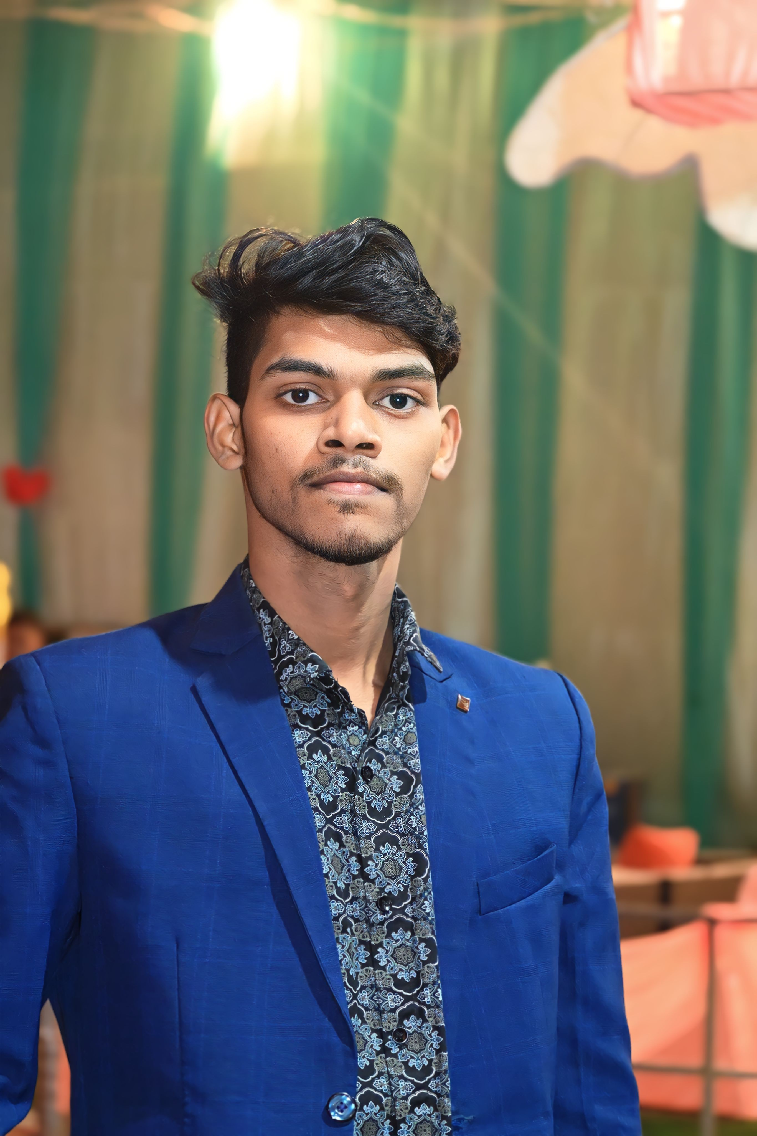

**RAVIDAS ANAND**

**CAREEROBJECTIVE**

* Secure a responsible career opportunity to fully utilize my talent and skills to grow, while making a significant contributiontothesuccessofthe company.

**CONTACTDETAILS**

* Mobile No. 8208614113
* Email id manojravidas1978@gmail.com

**ADDRESS**

* VILL- LUPUNG , KATKASHANDI,
* JHARKHAND , 825301

|  |  |  |  |  |
| --- | --- | --- | --- | --- |
| **Exam Name** | **Board / University** | **Passing year** | **Percentageof Marks** | **Division** |
| 10th | MSB | 2021 | 42% | 2ND |

* Domestic Data Entry Operator

WORK EXPERIENCE

* FRESHER

PERSONAL DETAILS

|  |  |
| --- | --- |
| **Date of Birth** | 03-02-2003 |
| **Father's Name** | MANOJ KUMAR |
| **Mother's Name** | KIRAM DEVI |
| **Nationality** | INDIAN |
| **Marital Status** | Unmarried |
| **Language** | Hindi |
| **Hobbies** | Cricket ,bolly ball |

Declaration:

Iherebydeclarethatallthestatementmadeinthisresumearetrue, complete and correct to the Knowledge.

Date:

Place: