**RESUME(CV)**

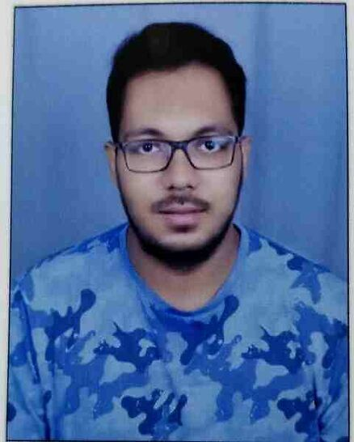

**SOUMESH DASMOHAPATRA**

**Address:** Flat No A 102, Banyan Courtyard, Bhagawanpur, Bhubaneswar, Odisha, India. Pin-751019

[soumeshdasmohapatra@gmail.com](mailto:soumeshdasmohapatra@gmail.com)

**Mobile No:** (+911) 9937505548,7978272001

**Career Objective:**

Seeking a career to utilize my knowledge, personal skills to gain comprehensive understanding of a reputed organization so as to take responsibility and contribute significantly.

**Educational Qualification:**

|  |  |  |  |
| --- | --- | --- | --- |
| **EXAMINATION** | **SCHOOL/COLLEGE** | **BATCH** | **PERCENT** |
| M.B.A in FINANCE | NIIS INSTITUTE OF BUSINESS ADMINISTRATION, BHUBANESWAR, ODISHA, INDIA | 2017-2019 | 62% |
| B.COM in MANAGEMENT HONOURS | BJB AUTONOMOUS COLLEGE, BHUBANESWAR, ODISHA, INDIA | 2014-2017 | 55% |
| 12TH (CHSE STATE BOARD) | KALINGA BHARATI RESIDENTIAL COLLEGE, CUTTACK, ODISHA, INDIA | 2011-2013 | 72% |
| 10th (ICSE BOARD) | S.C.B MEDICAL PUBLIC SCHOOL, CUTTACK, ODISHA, INDIA | 2011 | 52% |

**Computer Skills and Knowledge:**

* Microsoft Word
* Microsoft Excel
* Microsoft PowerPoint

**Academic Project:**

MBA Summer Internship at NIIS INSTITUTE OF BUSINESS ADMINISTRATION, BHUBANESWAR, Odisha, India.

Duration: 60 Days

**Achievements:**

* Received a laptop for my splendid performance in 12th Class.

**Hobbies:**

Surfing Internet

Travelling

Watching Movies

Jogging/Walking

Photography

**Personal Information:**

**Name:** Soumesh Dasmohapatra

**Father’s Name:** Sanjay Kumar Dasmohapatra

**Mother’s Name:** Jyotsna Dasmohapatra

**Date of Birth:** 14-01-1996

**Gender:** Male

**Caste:** General

**Nationality:** Indian

**Languages Known:** Odia, Hindi, English.

**Declaration:**

I hearby declare that all the above written particulars are true to the best of my knowledge and belief.

**Place: Signature:**

Bhubaneswar, Odisha, India. Soumesh Dasmohapatra