CURRICULUM VITAE

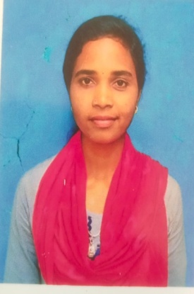

Name- GORIMANI JANI

At-MUNDARI GUDA,POST-PHUPUGAM,BLOCK-KUNDURA

Dist-KORAPUT(ODISHA)

Pin-764002

Cell-6370661763

E-mail:gourijani082@gmail.com

**OBJECTIVES**

To assist myself with an organization where there is scope for contributing and upgrading my knowledge for the development of self and organization served and seeking a career in challenging environment where my qualification, experience, logical and creative skills are used to maximum.

ACADEMIC QUALIFICATION

* 10TH GOVT(SSD)HIGH SCHOOL LIMA
* +2 BIJUPATTNAIK JUNIOR COLLAGE KUNDURA
* +3 BIJUPATTNAIK DEGREE COLLAGE KUNDURA

JOB RESPONSIBLITIES

* Advising on safety topic.
* Conducting risk assessments and enforcing preventative
* Measure. Updating policies, organizing training, inspecting premises, investigating incidents and reporting occurrences.
* Create and maintain in a safe environment.
* Identifying hazards, ensuring compliance with legislation, and promoting a culture of health and safety in the workplace.

STRENGTH

* Punctual and Sincere towards commitment.
* Determined, Dedicated and Result oriented approach.
* Willingness to learn with adaptability.
* Positive Attitude.
* Good Listener.
* Passion to achieve Goal

PERESONAL DETAILS:

Date of Birth :19-1-2000

Father’s name: Jajabandhu jani

Religion : Hindu

Marital Status: Unmarried

Nationality : Indian

Sex : female

Language knows: English, Hindi, Odia.

Hobbies : Writing Reading Playing

DECLARATION:

I hereby declare that all the statements mentioned above are true to the best of my knowledge and belief.