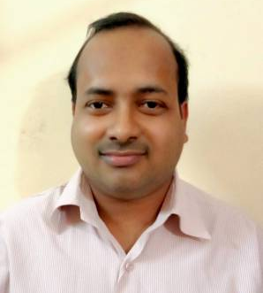
CURRICULAM VITAE

Phone:- 8770433208  E-mail:  raviv2882@gmail.com | Block-55/4 Nehru Nagar(East)  Bhilai, Distt- Durg (C.G.)
Ravi Verma
Objective:
Take up a challenging position in the company where my knowledge & experience can contribute towards the growth of the company & self.

Qualification:

Degree | Institute | University/Board | Percentage
B.E. (Electronics & Telecom), 2005 | Shri Shankaracharya College Of Engineering & Technology, Bhilai | Pt.Ravishankar Shukla  University,Raipur(C.G.) | 63%
H.S.C(1999) | S.S.S.Sec-X, Bhilai | CBSE | 51.2%
S.S.C(1997) | S.S.S.Sec-X, Bhilai | CBSE | 52.3%

Computer Proficiency:

➢C & C++ ➢ HTML PROG.
➢ Hardware & Networking ➢ Software Testing
➢ AutoCAD 2006

Project:

Project Name | Multipurpose Digital Counter
Team Size | 5

Seminars Rendered | Interview Skills by Edgemakers

Work Experience:

Name of Organization | Post | Experience
HCL Infosystems Ltd, Bilaspur | Professional Consultant | 1st July 06 to 31st Dec06
Satyam Engineering Services, Bhilai | Technical Consultant | 1st Feb 07 to 20th Mar11
Tech-India, Bhilai | Director (Admin) | 1st May 11 to 30th Jul 13
Buniyaad Academy, Bhilai | Centre Manager | 1st Sep 13 to 30th Feb 18
Dhl Infrabulls Samuh, Bhilai | Branch Head | 20th Mar 18 to 30th sep 18
Awign Enterprises | Exam Invigilator (online) | 18th Oct 18 to 10th Jan 23
Awign Enterprises | Exam Invigilator (offline) | 15th March 2023 to till date

Personal Details:

Name | Ravi Verma
Fathers Name | Shri R.N.Verma
Fathers Occupation | Ex-Lecturer(B.S.P.H.S.S.Sec-VIII)
Residence No. | 8770433208
Date of Birth | 28th November 1981
Language Proficiency | English, Hindi.
Permanent Address | Block-55/4 Nehru Nagar (East), Bhilai,  Distt.- Durg(C.G.)
Hobbies | Listening Music, Reading adventures books, Playing games, Watching movies

I hereby declare that the information given below is true to the best of my knowledge & belief.

Date: Ravi Verma
Place: BHILAI

