# RESUME

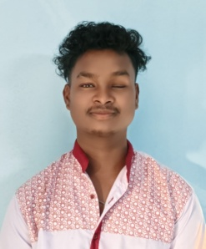

## SHYAM BHATRA

**Address: At/Po-Hadia, Ambaguda, Jeypore**

**Dist-Koraput, State-Odisha, Pin-764055**

**Mob.No:6371312368**

**Mail id: alexshyam69@gmail.com**

**Career Objective:**

**To work in an organization to explore my talent and ready to work challenging environment with efforts**

**Qualification:**

|  |  |  |  |  |  |
| --- | --- | --- | --- | --- | --- |
| **Sl.No** | **Standard** | **School/Collage** | **University/**  **Board** | **Year Of**  **Passing** | **Percentage**  **%** |
| **1** | **Matriculation** | **Govt U.G High School,Hadia** | **BSE, Odisha** | **2019** | **41.83** |
| **2** | **Intermediate** | **Kotpad H S School,Kotpad** | **CHSE, Odisha** | **2021** | **37.16** |
| **3** | **ITI (Electrician)** | **GITI, Ambaguda** | **NCVT, Odisha** | **2023** | **72.58** |
| **4** | **Fitter Electrical & Electronic Assembly** | **AISECT Skill development Centre, Koraput** | **AISECT Skill development Centre, Koraput** | **2025** | **Completed** |
| **5** | **Unicef** | **Unicef** | **NIIT Foundation** | **2024** | **Completed** |

**Skills:**

* **Decision making**
* **Team building**
* **Team work**

**Personal Details:**

**Candidate Name : Shyam Bhatra**

**Father’s Name : Late Banamali Bhatra**

**Date Of Birth : 28/06/2002**

**Age : 23**

**Gender : Male**

**Blood Group : O+**

**Matirial Status : Unmarried**

**Language : Odia, Hindi, English**

**Religion : Hindu**

**Declaration:**

I hereby declare that the fact and evidences given by me in the above application are true to the best of my knowledge.

(Signature of the Applicant)

Date: ________________